Current Research on Alternative Energy
Student’s Name
Institutional Affiliation
Date

Current Research on Alternative Energy
Among the vital scientific discoveries in an attempt to find an alternative to fossil fuels is hydrogen energy. Hydrogen, a clean fuel that produces only water vapor and warm air as a combustion product, has an analogous cycle to the natural carbon cycle with carbon not being involved, however (Zuttel et al., 2010). NASA, for instance, has relied on hydrogen gas as a fuel for decades to deliver crew and cargo to space (NASA, 2017). Whereas hydrogen is advantageous, in that requires no living matter in its production, it occurs as a gas at ambient conditions, thereby occupying large volume (Zuttel et al., 2010). Therefore, for efficient storage, its volume has to be reduced to be in equilibrium with the environment.
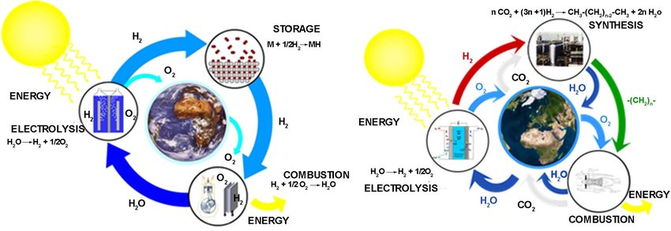
Figure1: Hydrogen cycle (left) and synthetic fuel cycle (right). Both cycles result in no net CO 2 emission.
With that said, hydrogen requires renewable energy (geothermal or solar power) for its production. The electricity from the renewable source is used for electrolyzing water and dissociating it into hydrogen and oxygen. The direct thermal dissociation of water, Zuttel et al. reports, requires temperature more than 4000K. However, it does produce not only hydrogen but also atomic hydrogen, hydroxyl ions, and oxygen, thereby requiring further separation of hydrogen gas from the elements, which is proving challenging. The derivation of hydrogen gas from natural gas and fossil fuels creates emissions, arguably counteracting its benefits as an alternative source.
Another alternative energy source several researchers are investigating instead of oil and its derivatives is the biodiesel energy. Among the alternative sources, biodiesel seemingly is an interesting one for several reasons, not limited to its minimal toxicity and biodegradability. In a comprehensive review journal, Atabani et al. (2012) argue that biodiesel can replace fossil fuel in many different applications, for instance, in internal combustion engines and boilers, without complex adjustments. In consequence, only a slight decrease in performance is experienced while, on the other hand, the emission of environmentally hazardous chemical substances, sulfates, and aromatic compounds reducing to nearly zero.
Vegetable oil-fueled engine invention dates back to the 1900s, its full exploitation coming into light in the 1980s, however. Biodiesel, according to Atabani et al., is mono-alkyl esters of long-chain fatty acids derived from animal fats or vegetable oil and alcohol with or without a catalyst. Reinstated, it produces no sulfur, less carbon monoxide, no net carbon dioxide, particulate matter, and more oxygen. In as much as it has been in use in several countries, including the US, Malaysia, Brazil, Germany, Indonesia, Italy, France, among other European countries, its production potential is much more. With its vast potentiality, it may be part of the sustainable energy mix in the future. Notably, its global annual production increased from 15 thousand barrels daily to 2000 thousand in 2008. As shown in the graph below, its production holds much promise in the future.
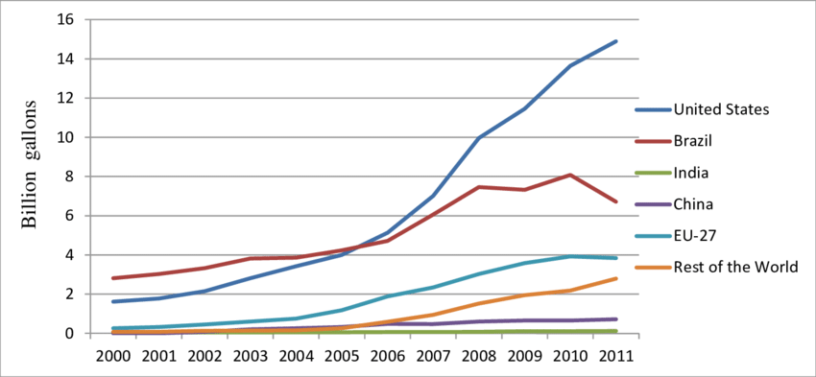
Figure 2: Graph by Getachew Nigatu on Global biofuel production from 2000-2011
Worldwide, researchers have identified more than 350 oil-bearing crops as potential biodiesel sources (Atabani et al., 2012). However, the authors assert, sunflower, soybeans, palm oil, coconut, rapeseed, and peanut are the first-generation feedstock. Being edible oils, usage of the above-listed feedstock raises concerns such as food versus fuel crisis, and destruction of critical soil resources. Furthermore, the economic viability of the biodiesel industry is in question following the recent dramatic rise in the prices of vegetable oil plants. The alternative source is therefore not economically feasible calling for the need for more research and technological development. Nonetheless, researchers recommend the use of non-edible oil, microalgae, and genetically engineered feedstocks to ensure the sustainability of the production.
Still, on exploring alternative energy sources to fossils, researchers have realized that oceans produce energy that could be harnessed into electrical energy. Wind creates surface waves by passing over the sea, after which the ocean stores the energy in the form of waves, tides, heat, and current (Owusu & Asumadu-Sarkodie, 2016). According to the later authors, it is until 2008 that the generation of commercial Ocean energy started, with the first units being installed in Portugal-Pelamis and SeaGen. Despite the industry making substantial progress since 2008, it is still at an early stage with several prototypes under test (Uihlein & Magagna, 2016). Some of the already existing challenges include the development of technology capable of proving the robustness and reliability of the energy source. Moreover, reducing not only the cost but also deployment and risk has been a vital challenge in the industry. Nevertheless, ocean energy is clean not only by not producing greenhouse gas emissions but also by having insignificant visual impacts.
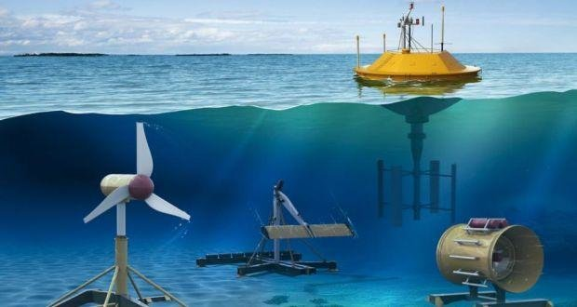
Uploaded by Athanasios- Valavanidis. EU Science Hub. New technologies in the ocean energy sector, 2018, https://ec.europa.eu/ JRC/en/news/new-technologies-ocean-energy-sector].
In elaborating how ocean energy works, different technological developments convert ocean waves energy into electricity. While in tidal energy, tidal range technologies harvest potential energy resulting from height differences in the tides. A precise elaboration on how ocean energy is converted can also be seen in a video via the link https://youtu.be/FHBVgRWAt3c. Also, researchers have developed tidal current technologies that capture kinetic energy flowing in and out of tidal areas. Nonetheless, its application is limited as researchers have reported that its theoretical global potential is between 20,000 and 92,000 TWh/year compared to 16,000 TWh/year world consumption (Esteban & Leary, 2012). Despite being a clean, renewable source of energy, it is relatively expensive compared to fossils. Besides, there is fluctuation in electricity produced, in that, during low wind and waves, ocean energy will produce little electricity in eventuality.
With the issues resulting from the use of fossil fuels becoming prominent and researchers anticipating depletion of the source in the coming future, it is imperative to have alternative fuels. Alternative fuel sources highlighted above are likely to gain more importance than they are now. Fortunately, alternative sources have several benefits alleviating the adverse impacts of fossil fuels not only on individuals but on society as a whole. For instance, whereas fossil fuel emits hazardous chemical substances, the alternative sources have little no emissions into the environment. Their technological advancements, however, have been slow considering the number of investments required to make them viable. Also, researchers have noted fluctuations to be an issue of concern in alternative sources. Nonetheless, investing in them will pay off by reducing pollution and having positive effects on climate change.

References
An Analytical Model for the Electrolyser Performance Derived from Materials Parameters - Scientific Figure on ResearchGate. Available from: https://www.researchgate.net/figure/Hydrogen-cycle-left-and-synthetic-fuel-cycle-right-Both-cycles-result-in-no-net-CO-2_fig2_320669694 [accessed 17 April 2020]
Atabani, A. E., Silitonga, A. S., Badruddin, I. A., Mahlia, T. M. I., Masjuki, H. H., & Mekhilef, S. (2012). A comprehensive review of biodiesel as an alternative energy resource and its characteristics. Renewable and sustainable energy reviews, 16(4), 2070-2093.
Esteban, M., & Leary, D. (2012). Current developments and future prospects of offshore wind and ocean energy. Applied Energy, 90(1), 128-136.
NASA. (2017). Space Applications of Hydrogen and Fuel Cells. Retrieved 17 April 2020, from https://www.nasa.gov/content/space-applications-of-hydrogen-and-fuel-cells
Owusu, P. A., & Asumadu-Sarkodie, S. (2016). A review of renewable energy sources, sustainability issues and climate change mitigation, Shashi Dubey (Reviewing Editor) Cogent Engineering, 3:1, DOI: 10.1080/23311916.2016.1167990
Uihlein, A., & Magagna, D. (2016). Wave and tidal current energy–A review of the current state of research beyond technology. Renewable and Sustainable Energy Reviews, 58, 1070-1081.
Züttel, A., Remhof, A., Borgschulte, A., & Friedrichs, O. (2010). Hydrogen: the future energy carrier. Philosophical Transactions of the Royal Society A: Mathematical, Physical and Engineering Sciences, 368(1923), 3329-3342.

